TsarTech

Nick Zamora

December 15, 2017

Project Design Documentation

Prototype 4

**Requirements and Intro:**

The diagram of the circuit and the requirements are shown below. This is not the final circuit but is a prototype with elements that we are most likely to use. Some of these components may change as decided by our team, and some undecided, physical components of the project will determine the unlisted electrical components. Prices of these electrical components may vary, and may be replaced upon availability.

**Product Requirements:**

* 1 - Aruino Uno: [Arduino Uno R3](https://www.adafruit.com/product/50)
* 2 - Motors: [STP-MTR-23055](https://www.automationdirect.com/adc/Shopping/Catalog/Motion_Control/Stepper_Systems/Stepper_Motors_-z-_Cables/STP-MTR-23055)
* 2 - Motor Drivers: [STP-DVR-6575](https://www.automationdirect.com/adc/Shopping/Catalog/Motion_Control/Stepper_Systems/Stepper_Drives_-z-_Power/STP-DRV-6575)
* 3 - Floating Liquid Level Sensors: [Uxcell Stainless Steel Liquid Level Sensor Switch](https://www.amazon.com/Uxcell-Stainless-Vertical-Sensor-Switch/dp/B016Q6S2VU/ref=zg_bs_306931011_27?_encoding=UTF8&psc=1&refRID=0VRT56H65AT79ZE9MH8E)
* 1 - Relay: [558-D1225](https://www.mouser.com/ProductDetail/Sensata/D1225/?qs=mNyg5qXQ%2FscRBV0ER4kpzA%3D%3D&gclid=EAIaIQobChMI_s2qwKOt1wIVF5J-Ch2wDgk9EAkYBSABEgJeEfD_BwE)
* 1 - Photoresistor: [Photo cell (CdS photoresistor)](https://www.adafruit.com/product/161)
* 1 - Voltage Regulator For 5V Supply: [L7805CV](https://www.mouser.com/ProductDetail/STMicroelectronics/L7805CV/?qs=9NrABl3fj%2FqplZAHiYUxWg%3D%3D&gclid=EAIaIQobChMIi_zmwp-F2AIVl7XACh3D0wJJEAkYASABEgIQCfD_BwE)
* 1 - LCD Breakout Board: [LCD Shield Kit w/ 16x2 Character Display](https://www.adafruit.com/product/772)
* 1 - Electronic Valve: [Plastic Water Solenoid](https://www.adafruit.com/product/997?gclid=EAIaIQobChMI2_nEjqWF2AIVB2x-Ch2MewYKEAkYASABEgLUJ_D_BwE)
* 1 - Flow Sensor: [Uxcell G1/2](https://www.amazon.com/dp/B01LQF6D4Y/ref=asc_df_B01LQF6D4Y5299839/?tag=hyprod-20&creative=395033&creativeASIN=B01LQF6D4Y&linkCode=df0&hvadid=198064502357&hvpos=1o1&hvnetw=g&hvrand=5592603812990128358&hvpone=&hvptwo=&hvqmt=&hvdev=c&hvdvcmdl=&hvlocint=&hvlocphy=9033043&hvtargid=pla-348578399216)
* 2 - Transformer for Powering Mechanics: [546-BF2G](https://www.mouser.com/ProductDetail/Hammond-Manufacturing/BF2G?qs=a2MtRaTmNOQCIp4W5lRelA%3d%3d)
* 1 - Rectifier Bridge for Mechanics Power Supply: [VS-KBPC8005PBF](https://www.mouser.com/ProductDetail/Vishay-Semiconductors/VS-KBPC8005PBF?qs=sGAEpiMZZMtQ8nqTKtFS%2fERhNCRzfcOND9YM4RhhbIQ%3d)
* 1 - Rectifier Bridge for Plasma Reactor:
* 1 - Transformer for Plasma Reactor:
* 1 - Voltage Regulator for Plasma Reactor:
* 3 - 6kΩ Resistors
* 1 - 1KΩ Resistor
* 1 - 18V Rated 5mF Capacitor
* 1 - 18V Rated 330nF Capacitor
* 1 - 5V Rated 100 $μ$ F Capacitor
* 1 – Diode 5V at least 7 – 12 mA rating
* 2 - LEDs
* 2 - Motor Heat Sinks:
* 2 - Motor Driver Heat Sinks:
* 1 - Relay Heat Sink:
* 1 - Arduino Heat Sink:
* 2 - Voltage Regulator Heat Sinks:
* 2 - Rectifier Bridge Heat Sink:
* 1 - Small Transformer Heat Sink:
* 1 - Large Transformer Heat Sink:
* 1 – Large Voltage Regulator Heat Sink:

**Price:**

* Aruino Uno: *$24.95*
* 2 - Motors: *$71.00*
* 2 - Motor Drivers: *$178.00*
* 3 - Floating Liquid Level Sensors: *$26.70*
* 1 - Relay: *$41.89*
* 1 - LCD Breakout Board: *$19.95*
* 1 - Electronic Valve: *$6.95*
* 1 - Flow Sensor: *$8.31*
* 1 - Transformer for Powering Mechanics: *$27.79*
* Smaller Electronics Including Resistors, Capacitors, and Diodes: *~$10.00*

**CURRENT TOTAL: $422.44**

**Power Requirements:**

Control System $≈$ 50W

Plasma Reactor $≈$ 300W

Total $≈$ 350W

**Circuit Diagram:** [Ctrl + Click (Cmd + Click for Mac) Here to View Online](https://www.circuitlab.com/circuit/dym5u783r367/biodiesel-circuit/) **–** Do not modify

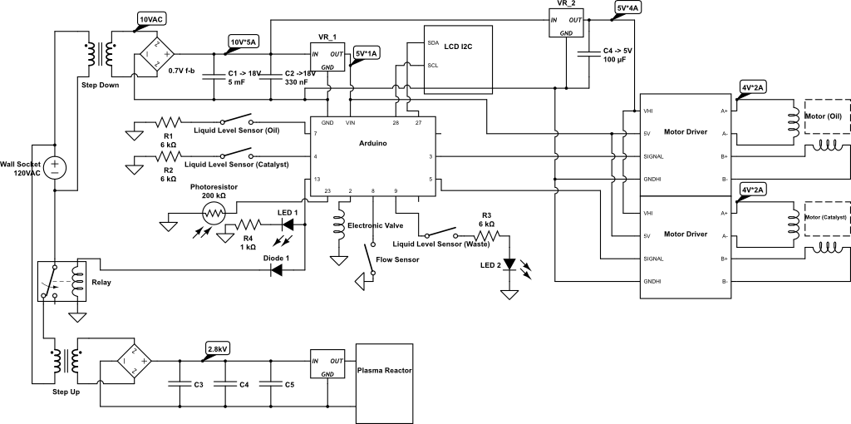

**Circuit Explanation:**

This circuit is for the use in the biodiesel converter machine. It is comprised of two main nodes. The top node is used for powering the Arduino, the motor/motor drivers, and any instrument that the Arduino utilizes.

Analyzing the top node: From the wall plug, a 120V AC source flows in to a step-down transformer. This transformer will have a turn ratio of about .083 to convert 120VAC to 10VAC. After it flows through the transformer, the electricity is then converted in to DC through a rectifier. This output DC voltage is used to power the motor drivers and the Arduino. The power flows in to a voltage regulator, this supplies the Arduino with the power necessary to power the Arduino system and the components it utilizes. This will also power the motor drivers.

The Arduino has 13 connections. The top two pins are used for powering the Arduino. 5V are supplied to the Arduino.

Pin 7 is connected to the Oil Level Sensor. This reads a Low signal unless the oil is out. In this case, Pin 7 will read a High input, and will turn Pin 13 Low. Pin 4 follows the same rules as Pin 7 but the sensor is in the catalyst reservoir. Pin 13 is connected to the relay which activates the plasma reactor. If a High signal is sent out of this pin, the reactor will turn on. Pin 23 is connected to a photoresistor. If this photo resistor senses light, a High signal will be sent to Pin 23. This will in-turn send a High signal to Pin 2. Pin 2 is connected to the Electronic Valve. If a High signal is sent through this pin, the electronic valve will make the oil flow to the main biodiesel reservoir. Otherwise, all liquids will flow in to the waste until this switch is activated. Pin 8 is connected to a flow sensor. Once this flow sensor detects that there is liquid flowing through the pipe, a high signal will be sent to Pin 8. This will then send a High signal to Pin 13, turning on the reactor.

Pins 28 and 27 are connected to an LCD screen with button inputs. This uses I2C protocol, and will display the information that the client specifies. The use will be able to interface with this display, as it is a breakout board that uses both the buttons and the LCD screen via I2C. Pin 5 is connected to the Motor Driver. This will send PWM pulses to control the speed of the motor. Pin 3 is connected to the other motor. This way the speeds can be proportional to each other, so that the liquid quantity can be calculated. These motors will be precise, as the motors are stepper motors and the Motor Drivers are good quality. Pin 9 is connected to another level sensor which is turned upside-down. Once the level of waste in the waste container is filled to the desired threshold, an LED will light up alerting the user to a full waste bucket.

On the motor drivers, VHI is connected to the positive terminal on the 5V source. The GNDHI is connected to ground. Both the drivers will have motors connected to their A and B terminals. The stepper motors are two-phase.

The bottom node is simply connected to an adapter which takes the 120V AC from the wall, and converts it to roughly 2.8kV and less than 100 miliamps. This will provide the reactor with power to operate its function.

**Arduino Diagram:**

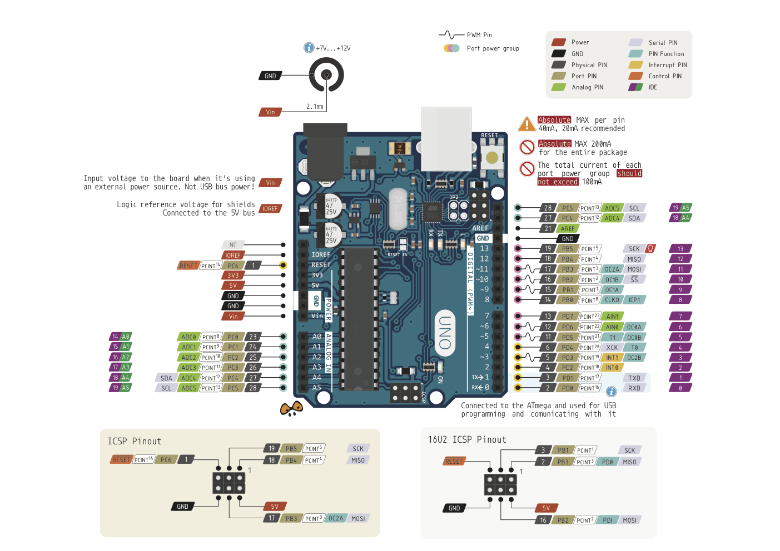

**Case For Arduino Usage:**

As requested by Khalid, a comparison of the Raspberry Pi and Arduino is provided here:

* Arduino is a micro-controller, Raspberry Pi is a microprocessor. The difference is that the Raspberry Pi has a Linux operating system installed typically, and is used for more complex, yet small, electronics. These electronics include and are not limited to; visual object tracking, threaded processing for gaming, hacking existing hardware that contain operating systems/ROMs, and complicated integrated systems. The Arduino is used for smaller scale projects as it is benchmarked much lower. It also is programmed directly and flashed by a computer. The Raspberry Pi can contain multiple programs and requires no flashing from a computer. The Raspberry Pi acts as its own HUB, where the Arduino uses Adruino IDE software that is on another computer to program it.
* The Arduino platform is integrated with many widely available products like the LCD screen we’re using, and other breakout boards. The open-source following for the Arduino is more vast than that of the Raspberry Pi when it comes to smaller projects. Especially pertaining to this project, where the most that needs to be done is control motors, activate switches, and read binary data.
* The Arduino is a cheaper alternative than the Raspberry Pi. The features included in the Raspberry Pi is unneeded for this project, as in only requires basic functions of an Arduino. This goes with power supply. The Raspberry Pi uses about 24W/h whereas the Arduino only uses about 8W/h. Although both are small amounts, this can add up in the big picture. Especially if this project is ever minimized for smaller quantity production, and needs to be battery Powered.

**Conclusion:**

The Arduino is the best choice for this project, as it requires little power, it’s cost-effective, and would be suitable for satisfying all the functional and non-functional requirements of this project. Using a Raspberry Pi would be a waste of money, time, and resources. The Raspberry Pi is far more complicated than what this project requires.